THE PENNSIC FLOOR
Last update - January 14, 2004 by Adele

Inventory (Pennsic 32):

1 Wood Graining tool
4 Paint rollers
- Paint roller brushes
- Mini-roller
- Foam brushes
Assorted buckets w/lids (5-10)
- Half rolls of masking tape (need more painting tape)
- Stirring sticks
- One inch brushes (YUCKY ONES!)
- 2.5” brush
- 2” brush
- Mallets (Could use 2 more) -- ask Pennsic tech if they have ones to borrow
Assorted small brushes and pencils
- Permanent marker
- Church key
- Yard sticks
- Mop heads(need more yearly – they get nasty)
- Hand sponge
- Paint trays
- Can of mini bungees for putting up sides of tent (possibly need one more)
- Paint chip stick
.5 Murphy’s Oil Soap (need more)
- Buckets of shims (could use a better container for all the shims)
Assorted 2x4 scrap.
- Hinges
  - Pounds of extra deck screws.
.25 Gallon of Thompson’s Water Seal
  - bucket of Border Color(Lamp black 44, Brown Oxide 11, White 18, Magenta 22)
  - Bucket of Medium Brown
.5 Gallon of Primer
.5 Gallon of Light Floor Background(white 3, raw umber 2, exterior red 37, Medium Yellow 40)
10 robinson/squarehead bits (should be in a brown paper bag)
1 plastic footlocker for décor
white plastic table cloth
yellow flower garland
fake lilacs
autumn leave garland

Floor set-up:
1. Center poles need to be set in a straight line with strings between them to guide layout along a center line. These poles can be moved by two strong people. The ground being relatively wet during Pennsic 32 may have facilitated moving them, so if there is difficulty in a dry year, try watering the ground.

2. Tarps down – assuming the same size tent as Pennsic 32 (3 center poles), the four corner poles define the western and eastern ends of the dance floor.

3. Lay out A and B floor joists – A’s are longer than B’s. A’s are on the north side and extend the width of center poles. B’s go on the south side and their ends are flush with the south edge of the poles. | 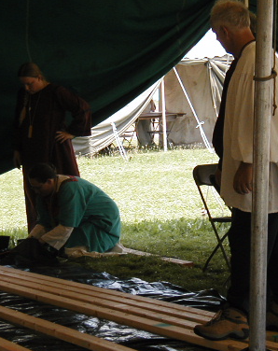

4. Add sleepers, including one that is shorter to fit between a joist and the western center pole. A’s must extend beyond center enough to get to edge of center sleepers – the sleepers do NOT touch the B’s.

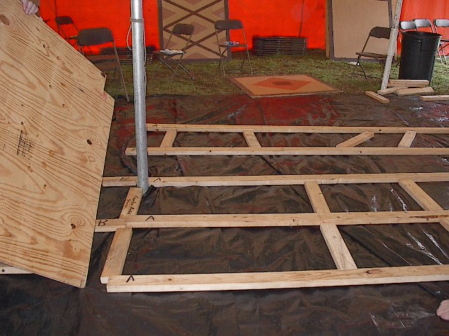 | 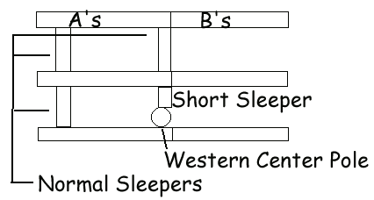
Photograph is a view from the east, looking west. Notice, we were bad and did not put down a string. It was not fun trying to pick up a huge section of floor and rotate it around the pole to fix it.

Diagram is a view from the west, looking east.

5. Start at west center pole with the notched, half sheet that is blank. The notch is along the tongue side of the TG plywood. On all pieces of the main floor, the tongues go to the west (Tongues To Troll). Again, photograph is from the east, diagram is from the west.

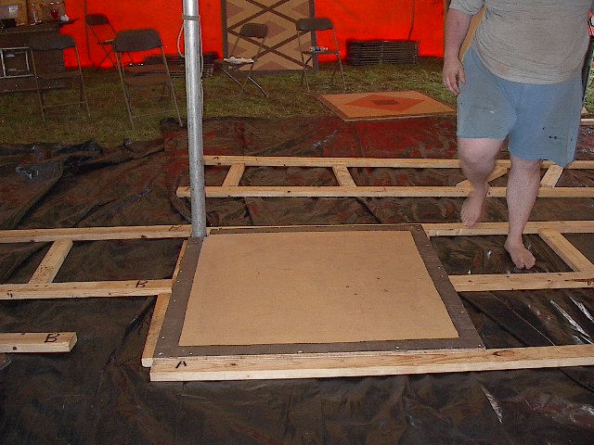 | 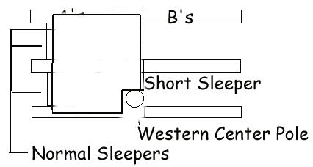

6. Assemble as above with decking screws through the floor and into sleepers and joists, setting straight according to the string line.

7. Another half-sheet goes against the north side of the notched piece, and three other full pieces complete the row. As each row gets laid out, double check on ends of joists to make sure that 3.5 inches is available for the edge 2x4’s that are put in last. This needs to be done before floor sections are screwed into the joists.

8. Sleepers and joists get laid out beside this row for the next row. While the pictures below show a sleeper at every four feet, they only need to be under the seams between floor sections. Generally, the seam placements are offset by four feet (half of a floor piece) each row. There are not enough sleepers to layout according to the pictures for the entire floor.

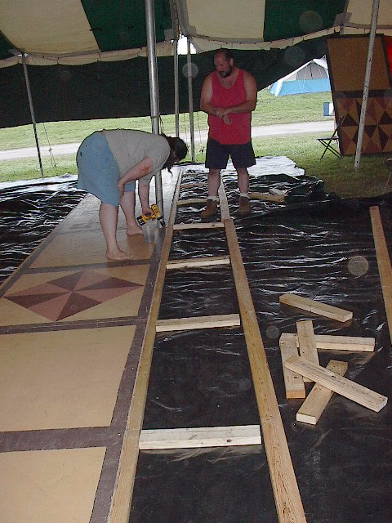 | 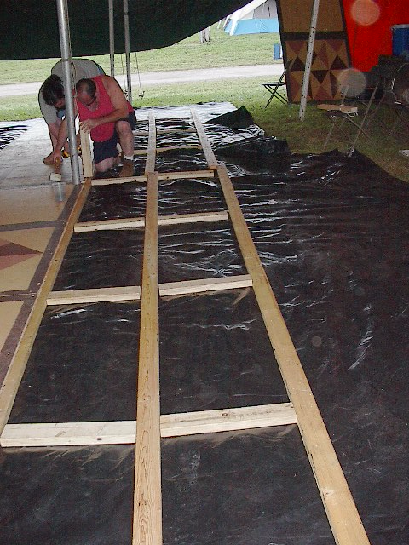
9. As sections are added, screw down only one side of a floor section. Then fit the next section to the other side, and screw along that seam. Fit front to back. Use mallets and scrap lumber to fit sections into place. As new rows get laid down, use shims under joists where there are depressions. Not doing this caused problems in Pennsic 32! Shim as you go and keep centered on the line established by the string. | 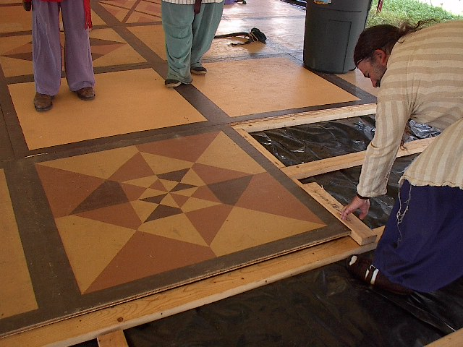
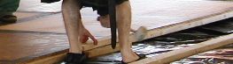 | 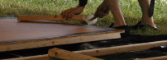

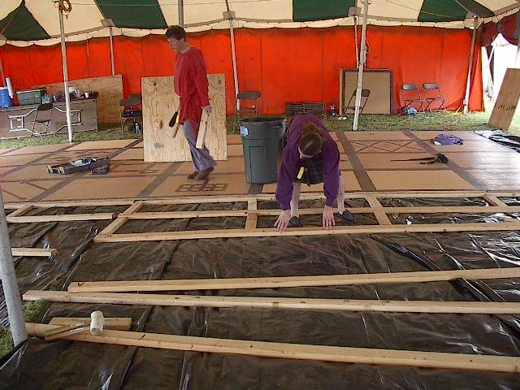 | Remember, sleepers only go under the seams between floor sections, not every four feet regardless of what is above them. They can be placed temporarily while laying out the joists and sleepers, but then the appropriate ones should be taken out before the floor sections are put down.

The sleeper layout should look more like the pictures here. At right, there is no sleeper in the lower left corner, where the last floor pieces show an intersection. The sleepers go where the new line of floor pieces will have an intersection.  Below, the correct spacing of sleepers can be seen. |  | 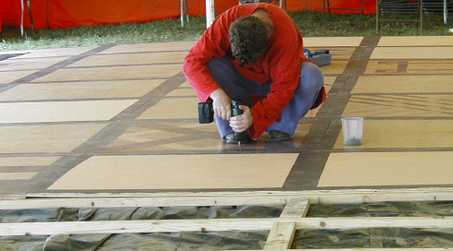
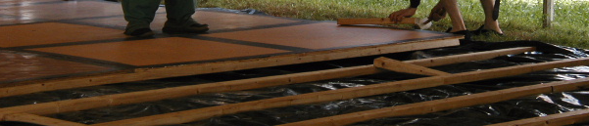
10. As floor sections are being placed, keep watch for the notched 4x4’ sections that are for the center poles. This is a fussy step, but the center poles can be moved a little bit with difficulty. | 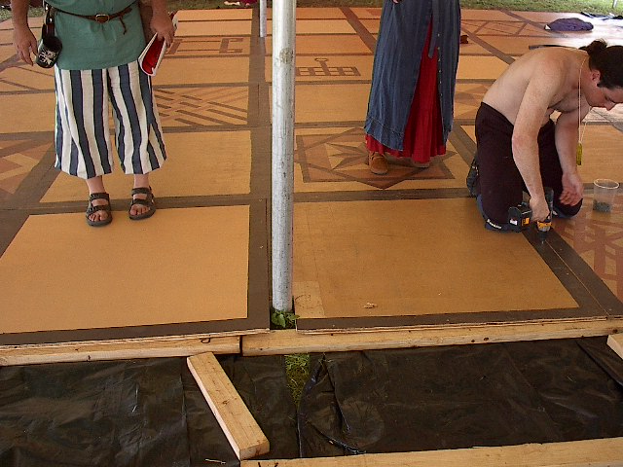

11. The goal, as floor sections are set out, is to eventually make a checkerboard pattern. This isn’t entirely possible as sections have been painted. Most sections, when viewed with the tongue at the top, have been painted with the right side a parquet. New sections should be painted in this manner. Sections that were painted on the left side were put aside until needed for the last few rows at the eastern end of the floor. The checkerboard design was maintained by not offsetting one row from the one next to it.

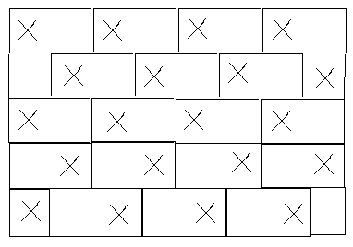

12. Some sleepers are labeled 18.75. These are used at the ends of the floor so that the last joists fit under the last row of floor.

13. C sections get placed under the long edges of the floor. Hopefully, people have been making sure that all joists are 3.5 inches in from the ends of the floor so these 2x4’s fit evenly!

14. Layout of the musician’s area is shown to the right. In general, pieces that are splintered from rain damage or mispainted go here because of less fast-paced foot traffic. Someone sitting is much less likely to trip over a splinter than someone who is dancing, and this area is more likely to get wet being at the very edge of the tent. | 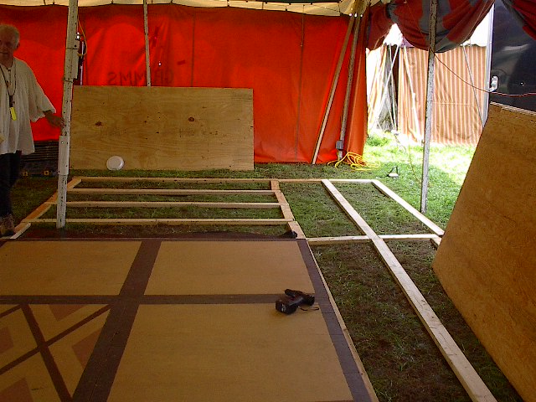
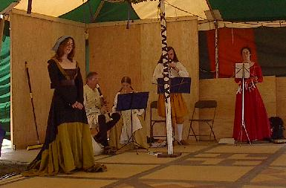 | There are wall sections for a band shell, but it was only put up the first year of the floor. This really should be put up, as it keeps drafts from the musicians and directs their lovely music to the dancers. Suggestions have been for faux finishing or trompe l'oeill.
15. Use small brown painted blocks as trim to cover the gaps at the center poles.

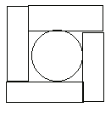
If any corner poles are on the floor, such as at the musician’s area, put a sleeper or scrap of wood beneath the floor where the pole will end up. Lift the pole and put on floor, over the wood piece. Blocks get put around, like at center poles.

Photos of the completed floor:

To the right is a normal view dancers see. Below is the floor from Arthur’s more precarious perch atop the center poles -- the first at the east end looking west, the second from the west end looking east. The second is flipped upside down to match the orientation of the first. | 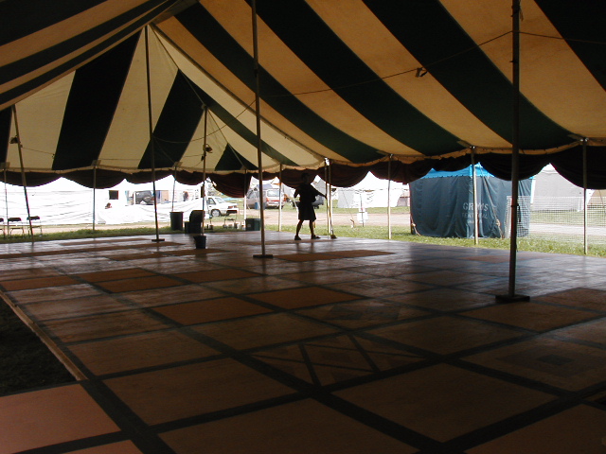

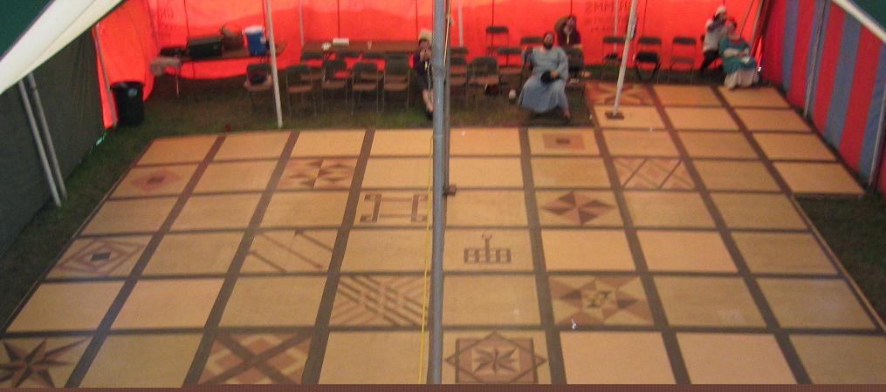

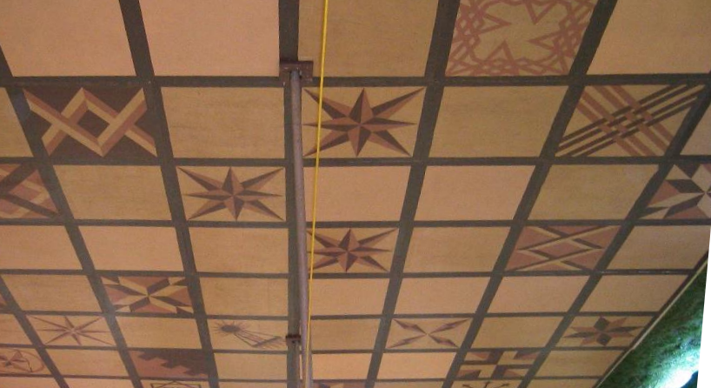

Timeframe (based on Pennsic 32):

The first two rows of floor, which involves a lot of slow, “fussy” work, took three people about 5 man-hours.

The rest of the floor took about 50 man-hours to assemble.

Breakdown and packing of the floor took about 20 man-hours.

Commentary from Pennsic 30:

(Phlip, you got anything to say?)

Commentary from Pennsic 31 and 32:

In both set-up and breakdown, things would move more smoothly with MORE drills that are FULLY CHARGED. After the initial start, both screwing and unscrewing are the most time-consuming tasks. For takedown, it might work to have a team with drills descend on the floor to pull out screws an hour or so before people to pick up and load pieces arrive.

Munchies during floor assembly are good! Pennsic 31, we flat-out brought in sandwich fixings, but that tends to slow things down. Less is more in this case. Pennsic 32, we had things such as sausage, cheese, vegetables and dip, pita and hummus, fruit, and cookies. It worked out better.

Some of the 4x4 foot sections of floor are looking pretty sorry and would be ideal for moving to the musicians’ area, although an 8x4 piece may need to be cut in half to replace them in the main dance area. The plan is to only cut floor sections that do not follow the right-side parquet idea to help encourage the checkerboard pattern.

At least 21 more designs need to be painted. Dirty screw heads are very bad, do not want to cooperate, and should be cleaned out. A power strip and extension cords would be nice.

Adele

Commentary from Pennsic 33

Commentary from Pennsic 34
Musician’s area was changed slightly – less likely to get wet from sticking out slightly

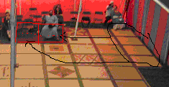

Sections for band shell were completed. However, they are not yet assembled in such a way that they can stand up. They worked okay leaning against the side walls of the tent, but there’s got to be a better way. They were going to be hinged together, which should work okay so long as the end sections get attached to the floor itself so the whole thing doesn’t act like a sail in a surprise storm, perhaps.

A few other pictures from assembly this year are below. They show specifics on how far over the A joists are supposed to be from a line marked by string at the sides of the center poles. DO SET THE STRING LINE…. It saves many headaches.


